Power BI Assignment 2 – DAX & Data Visualization

Calculated Columns:
Create a Calculated Column for 'Category Type':
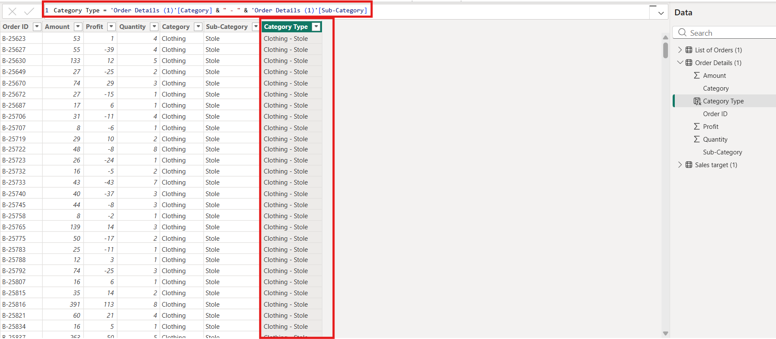
Calculate Revenue per Order in Order Details Table:
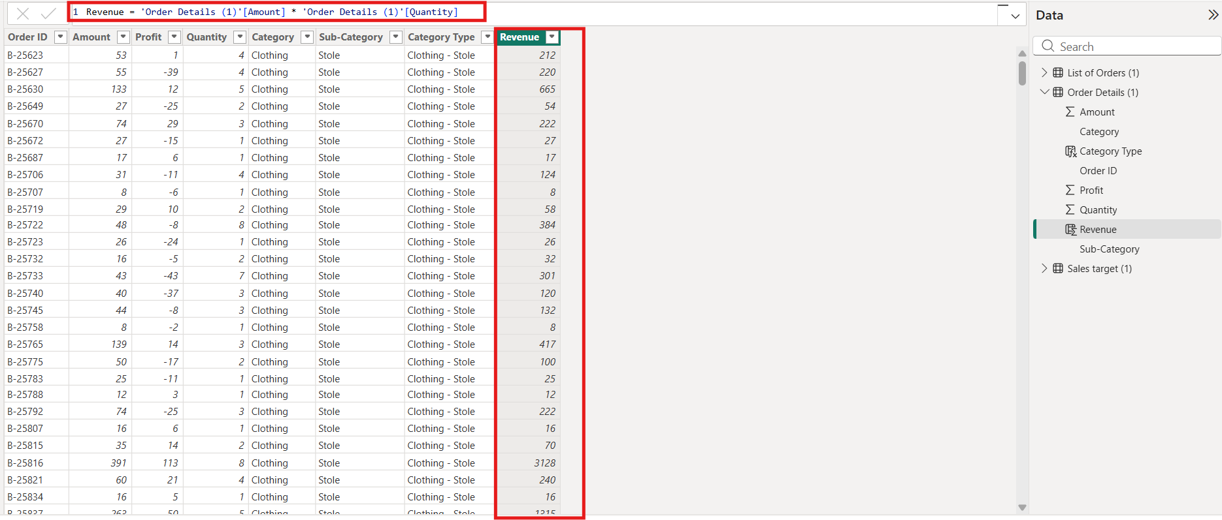
Create a Calculated Column to Categorize Sales:
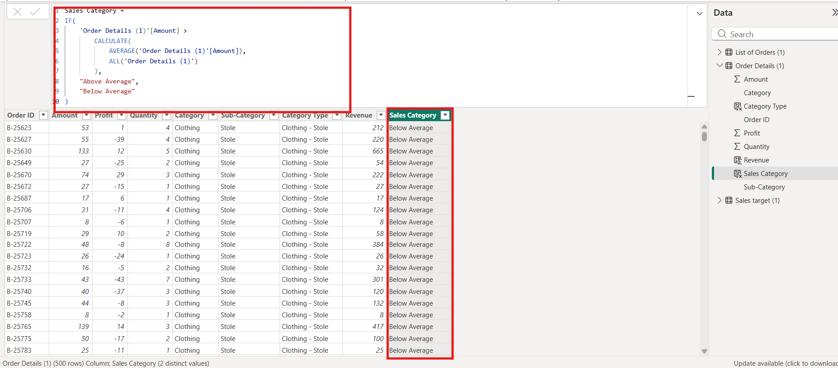

Calculated Measures:
Order Count
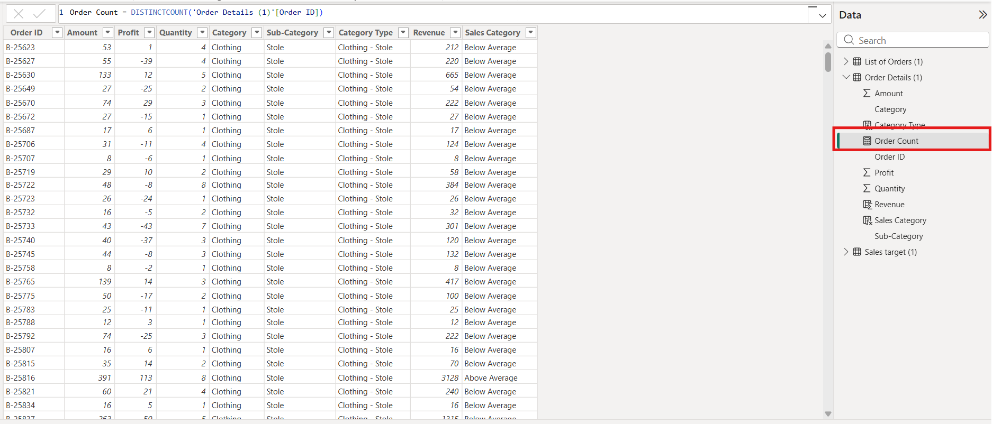
Average Profit in Delhi
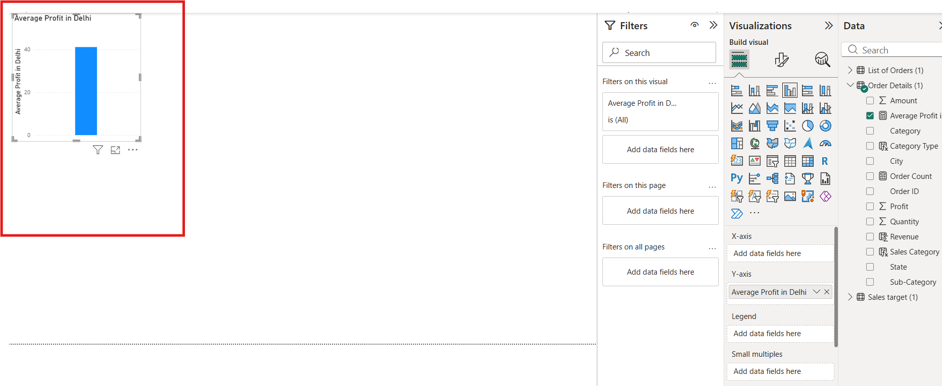
Year-to-Date (YTD) Sales
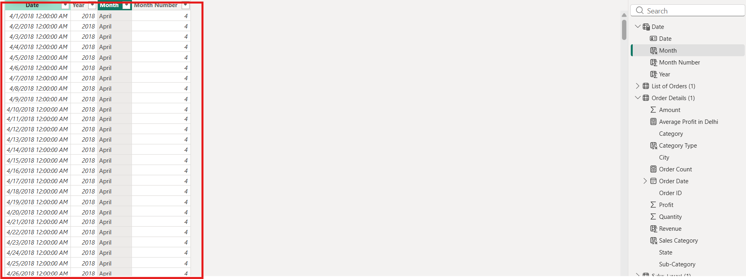
Data Visualization
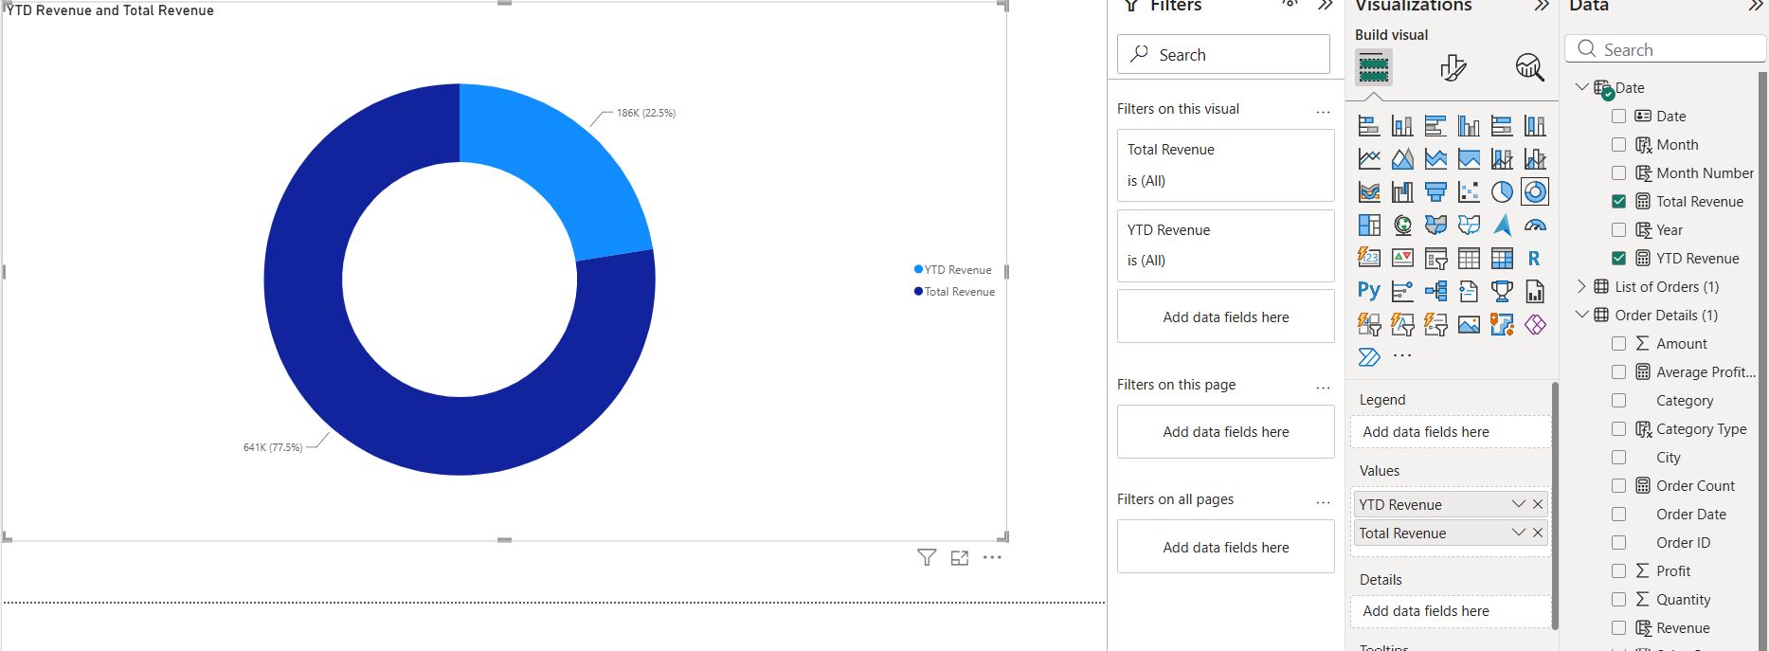
Sales Target Achievement by Category
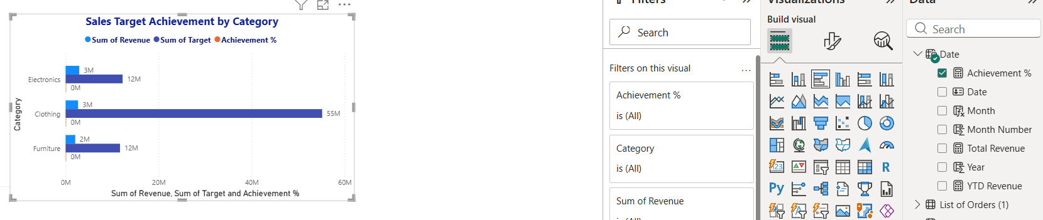
Max Profit Margin by Sub-Category
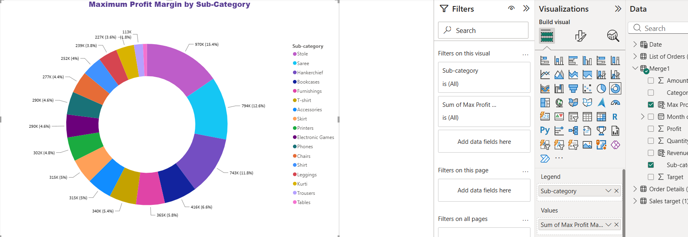
Monthly Sales Trend
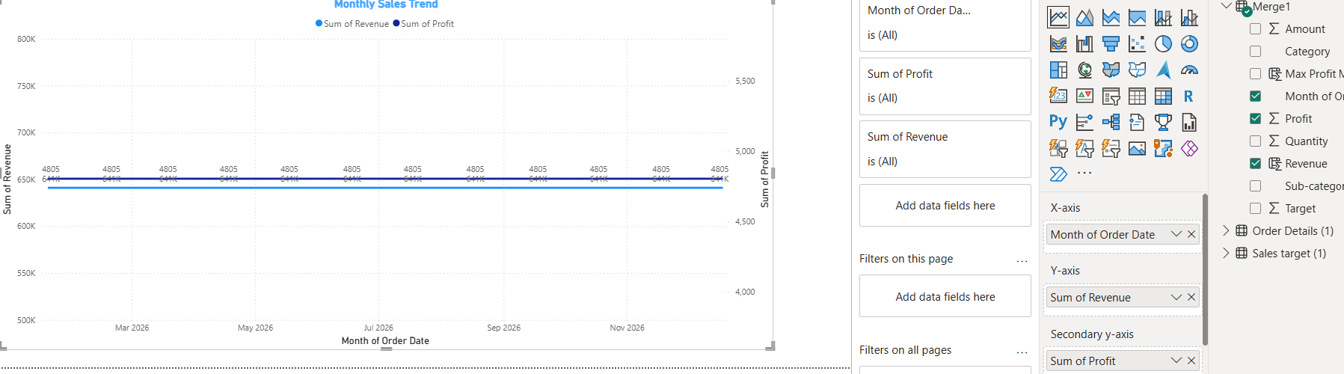
Comparison of Profit and Quantity by Sub-Category
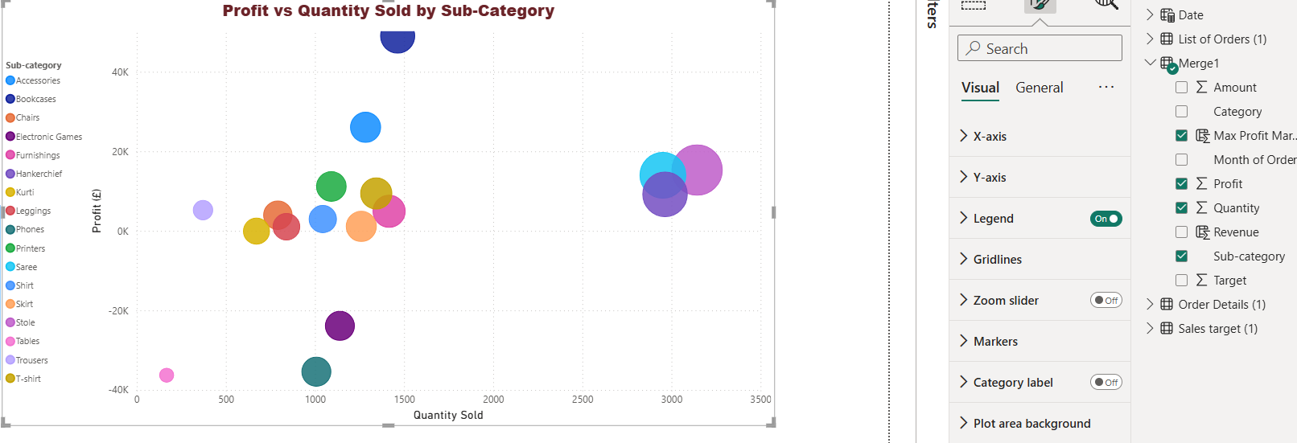
Comparison of Total Sales Amount and Target
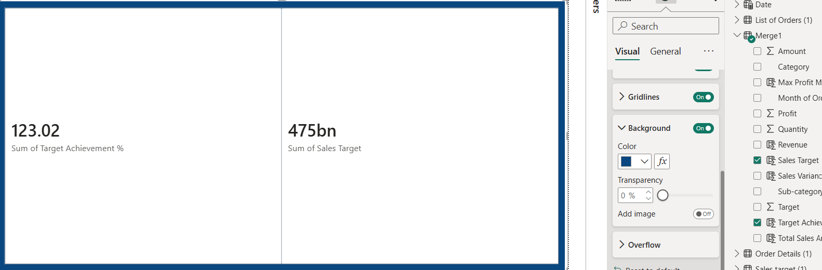
Sales Performance Matrix
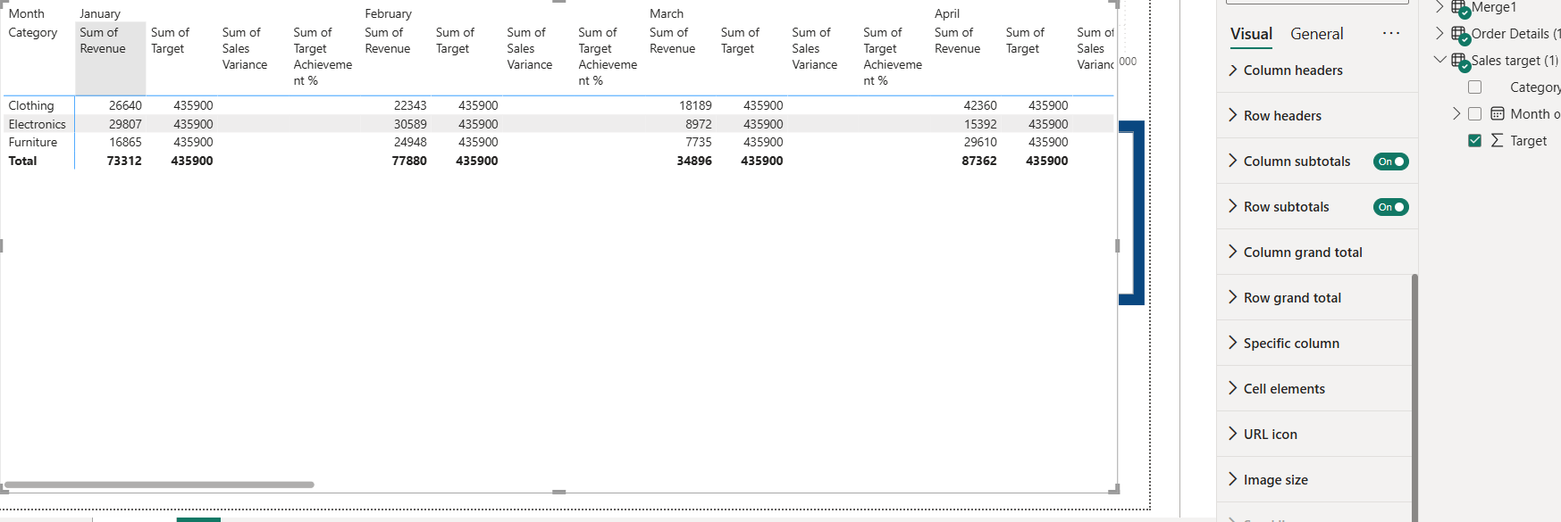
Sales Distribution by Sub-Category
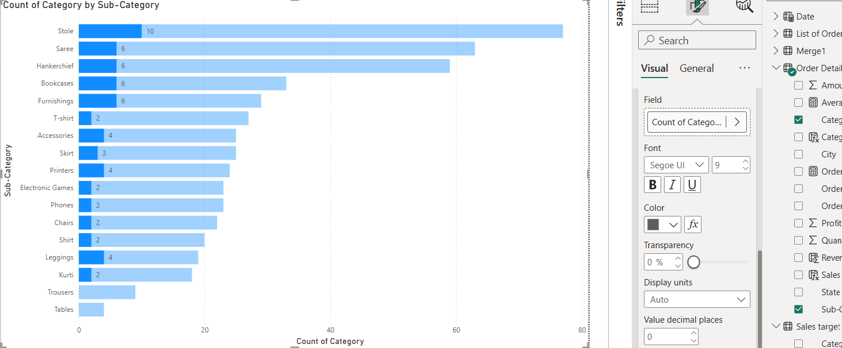
sub-categories using a treemap
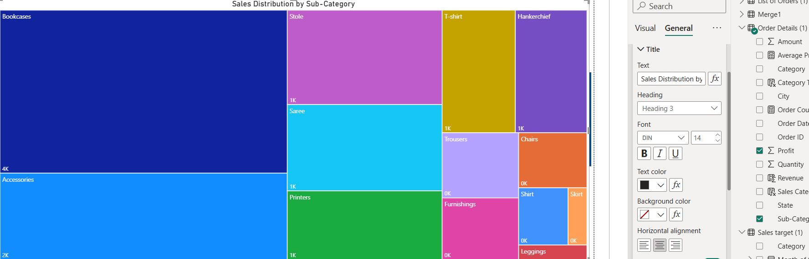
Order Count Analysis by State
